*Florida International University*

*School of Computing and Information Sciences*

Software Engineering Focus

Feature Document

#767 Dynamic Stack Interface Scene

**Name: Daniel Khawand**

**Team Member(s): Bernardo Pla, Daniel Rivero, Pachev Joseph, Hamilton Chevez**

**Project: WebVR 1.0**

**Product Owner(s)**: Francisco Ortega

**Mentor(s)**: Francisco Ortega

**Instructor**: Masoud Sadjadi

**User Story Name: Dynamic stack interface scene**

* As a user, I want a dynamic Stack Interface Scene where I can push and pop data items onto a stack in a WebVR or WebGL environment.

Acceptance Criteria

* Illustrates LIFO property
* Visualization of data
* Real-time user-scene interaction

**Use Case**

* Name: Stack Scene
* Actor: User
* Preconditions: Website accessed, WebGL Supported by browser
* Description: The user accesses the visual demo and then gets to push boxes onto a stack and pop boxes off afterward. If the stack is empty and the user requests to pop, an error message returns.

**Use Case Diagram <**you can use draw.io**>**

**Sequence Diagram**

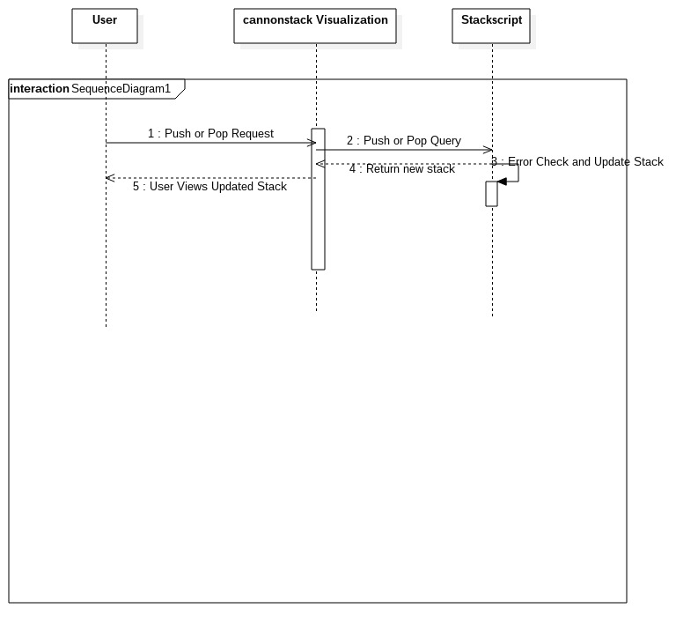

**Class Diagram**

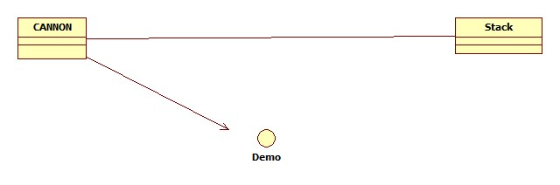

**Unit Test**

* Test case ID:
* Description/Summary of Test:
* Pre-condition:
* Expected Results:
* Actual Result:
* Status (Fail/Pass):

**Integration Test**

**Visual User Guide** <like one or two screenshots of the feature. For the hardware project, a photo of device is required>